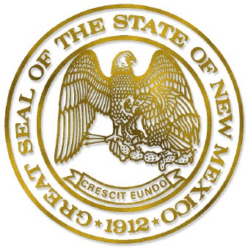

**Board of Directors:**

**Tom Sullivan**  
Chair

**Joe Montaño**  
Vice Chair

**Doug Crandall**  
Secretary

**David Archuleta**  
Executive Director

May 31, 2018

To: New Mexico Retiree Health Care Authority Board of Directors

From: David Archuleta, Executive Director

Re: Designation of Officer in Charge of Rulemaking Amendment to NMAC 2.81.11 — ESTABLISHING SUBSIDY LEVELS ON THE BASIS OF AGE AND YEARS OF CREDITABLE SERVICE

In 2015, the New Mexico Retiree Health Care Authority Board of Directors voted to implement a minimum age requirement of 55 for those retiring from state agencies and eligible participating public entities beginning January 1, 2020. The board also voted to increase the years of creditable service to receive the maximum subsidy from 20 years to 25 years, also beginning January 1, 2020.

The purpose of these measures is to help NMRHCA’s long-term solvency, as well as put the agency’s policies more in line with the Public Employees Retirement Association of New Mexico and New Mexico Educational Retirement Board.

The NMRHCA is authorized to promulgate rules to implement the Retiree Health Care Act, NMSA 1978, Sections 10-7C-1 to -16 (1990, as amended through 2009) (“Act”) by NMSA 1978, Section 10-7C-7 (1998). By resolution dated May 8, 2018, the NMRHCA resolved to undertake the rulemaking in conformity with the Act, the State Rules Act, NMSA 1978, Sections 14-4-1 to -11 (1967, as amended through 2017), the Default Procedural Rule for Rulemaking, 1.24.25 NMAC (4/10/2018) and the Open Meetings Act, NMSA 1978, Sections 10-15-1 to -4 (1974, as amended through 2013).

I hereby designate Greg Archuleta, Director of Communication and Member Engagement, to serve as the Public Comment Officer and agency represented in charge of the rulemaking procedure for NMAC 2.81.11. He will be the contact for any and all electronic and written information and comment from the public and will preside over the public rule hearing.

